AMERICAN INTERNATIONAL UNIVERSITY–BANGLADESH (AIUB)
FACULTY OF SCIENCE & TECHNOLOGY


CSC 2108: Introduction to Database
Fall 2023-2024
Section: F, Group: 01

Project Title
Tourism Management System

Supervised By
Razuan Karim
Associate Professor,Faculty,
Department of Computer Science.
Submitted By:
Name | ID
1.MD.Wahiduzzaman Khan Dip | 22-48505-3
2.MD.Khalid Hasan | 22-48930-3
3.MD. AL Faysal | 22-48345-3
4.Estiak Rahman Ayon | 22-49753-3

TABLE OF CONTENTS

TITLE PAGE Page -1

INTRODUCTION Page -3

GANTT CHART Page -3

CASE STUDY Page -4

ER DIAGRAM Page -5

NORMALIZATION Page –(6-14)

FINALIZATION Page -15

TABLE CREATION Page –(16-23)

DATA INSERTION Page –(24-31)

QUERY TESTING Page –(32-46)

DATABASE CONNECTION Page –(47-51)
CONCLUSION Page -51

INTRODUCTION
Organizing travel plans has grown more difficult in the fast-paced world of today. Our project is based on a tourism management system that aims to establish a comprehensive and efficient solution for managing travel arrangements. This project aims to simplify the process of storing and retrieving important travel-related data, including reservations for flights, hotel booking, meals, and other accommodations, by building a centralized database. By successfully implementing this project, the travel industry can benefit from improved efficiency and seamless travel experience for both travel agencies and individual users.

GANTT CHART

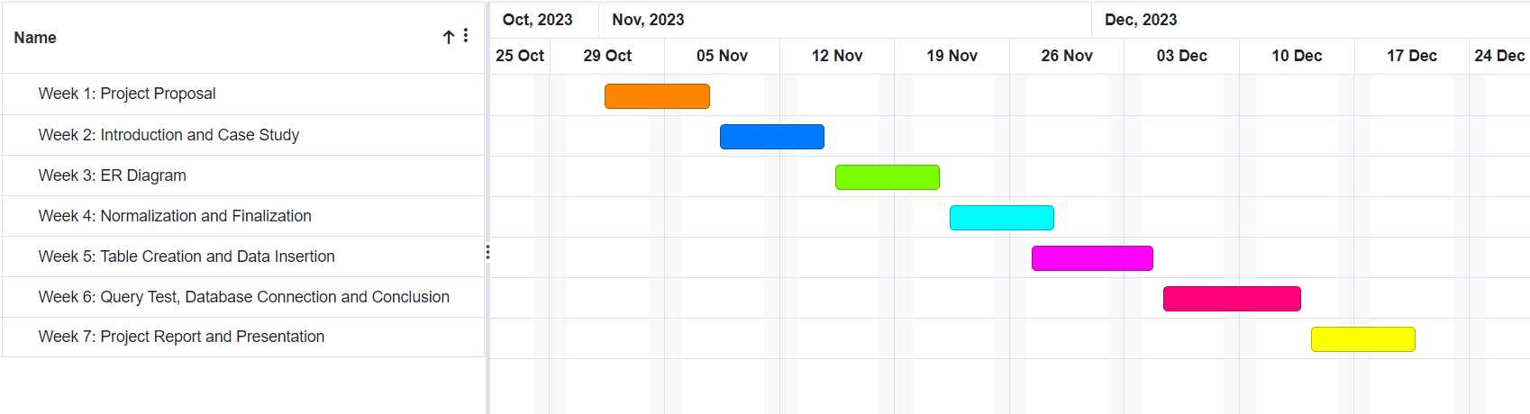

CASE STUDY
In a tourism management system, a travel agency employs several employees to handle various tasks. Various types of employees work for a travel agency. A travel agency usually contains an agency ID, name, address, phone number, and email address. On the other hand, an employee has an employee ID, name, date of birth, job type, salary, and different skills. Customers can approach a travel agency. A travel agency services many customers. A customer registers with a customer ID, name, address, phone number, email, and membership level. All kinds of addresses are composed of city, country, and zip code. A customer makes payments for various facilities. A payment process may include Pay ID, amount, date, etc. A customer takes flights for traveling. A flight includes flight number, airline, departure and arrival which is composed by country and time. A customer uses various types of local transportation. Local transportation generally has a transport number, booking date, pick-up location, drop-in location, and mode of transport. Customers make reservations at hotels. On the other hand, A hotel offers accommodations to the customers and the customer gets accommodations. To make accommodations, there is an accommodation ID, in date, out date, room type and room number. A hotel manages food booking. Different types of food bookings are offered by a hotel. Food booking is maintained by booking ID, booking date, meal type, and total number of guests. In total, there are 9 entities in the project.

ER DIAGRAM

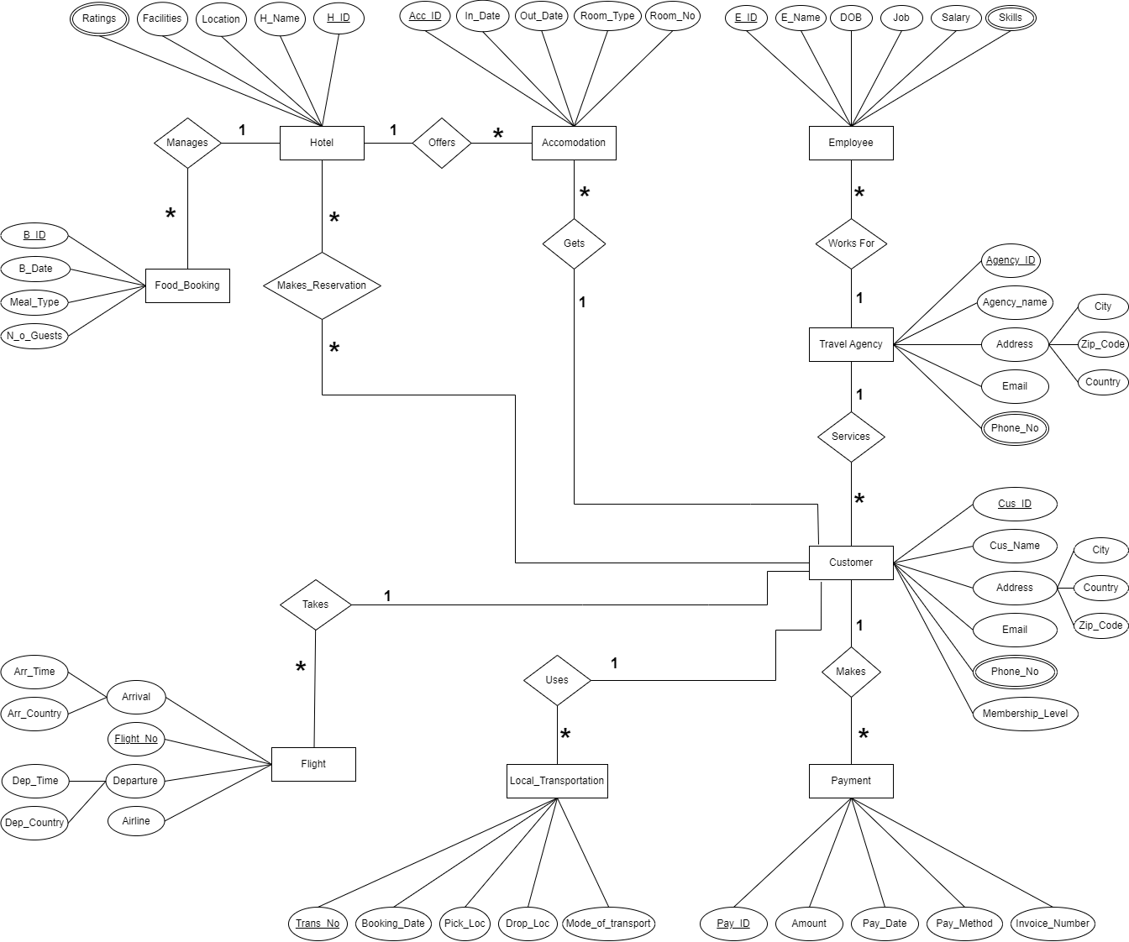

Fig-1: ER-Diagram for Tourism Management System

NORMALIZATION

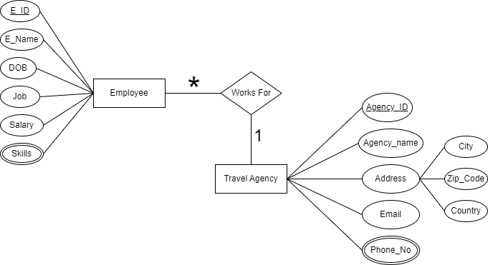

Fig-2: ER-Diagram for Employee – works for – Travel Agency

Relation: Many to One
UNF: Agency ID, Agency_Name, City, Country, Zip_code, Phone_No, Email, E_ID, E_Name, DOB, Job Title, Salary, Skills
1NF: Multivalued attributes: Phone_No, Skills.
Agency ID, Agency_Name, City, Country, Zip_code, Email, E_ID, E_Name, Date of Birth, Job Title, Salary

2NF: 1. Agency ID, Phone_No
- E_ID, Skills
- Agency ID, Agency_Name, City, Country, Zip_code, Email
- E_ID, E_Name, DOB, Job Title, Salary, Agency ID

3NF: 1. Agency ID, City, Country, Zip_code
- Agency ID, Phone_No
- E_ID, Skills
- Agency ID, Agency_Name, Email
- E_ID, E_Name, DOB, Job Title, Salary, Agency ID
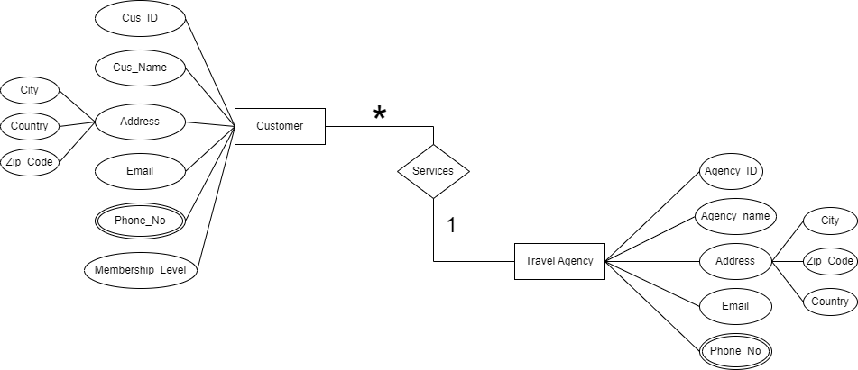
Fig-3: ER-Diagram for Travel Agency – services – Customer

Relation: One to Many
UNF: Agency ID, Agency_Name, City, Country, Zip_code, Phone_No, Email, Cus_ID, Cus_Name, City, Country, Zip_code, Email, Phone_No, Membership_Level
1NF: Multivalued attributes: Phone_No, Phone_No.
Agency ID, Agency_Name, City, Country, Zip_code, Email, Cus_ID, Cus_Name, City, Country, Zip_code, Email, Membership_Level
2NF: 1. Agency ID, Phone_No
  - Cus_ID, Phone_No
  - Agency ID, Agency_Name, City, Country, Zip_code, Email
  - Cus_ID, Cus_Name, City, Country, Zip_code, Email, Membership_Level, Agency ID

3NF: 1. Agency ID, City, Country, Zip_code
- Cus_ID, City, Country, Zip_code
- Agency ID, Phone_No
- Cus_ID, Phone_No
- Agency ID, Agency_Name, Email
- Cus_ID, Cus_Name, Email, Membership_Level, Agency ID
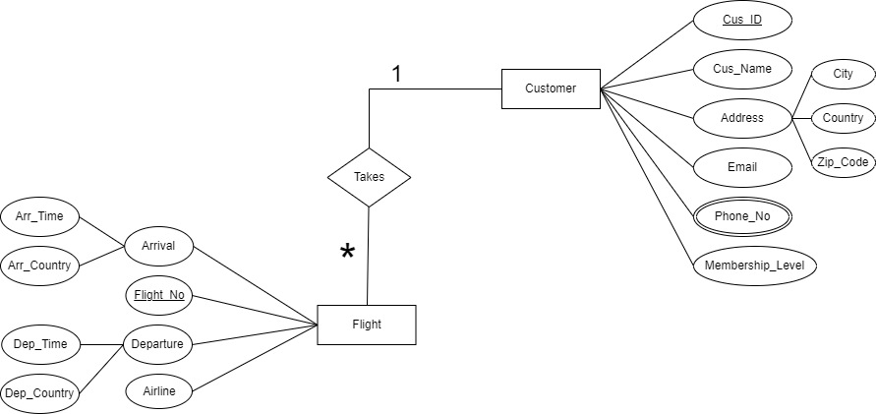

Fig-4: ER-Diagram for Customer – takes – Flight

Relation: One to Many

UNF: Cus_ID, Cus_Name, City, Country, Zip_code, Email, phone_no, Membership_Level, Flight_No, Airline, Dep_Country, Arr_Country, Dep_Time, Arr_Time
1NF: Multivalued attributes: Phone_No
Cus_ID, Cus_Name, City, Country, Zip_code, Email, Membership_Level, Flight_No, Airline, Dep_Country, Arr_Country, Dep_Time, Arr_Time

2NF: 1. Cus_ID, Phone_No
2.Flight_No, Airline, Dep_Country, Arr_Country, Dep_Time, Arr_Time, Cus_ID
3.Cus_ID, Cus_Name, City, Country, Zip_code, Email, Membership_Level

3NF: 1. Cus_ID, Phone_No
- Flight_No, Dep_Country, Arr_Country, Dep_Time, Arr_Time
- Cus_ID, City, Country, Zip_code
- Cus_ID, Cus_Name, Email, Membership_Level
- Flight_No, Airline, Cus_ID

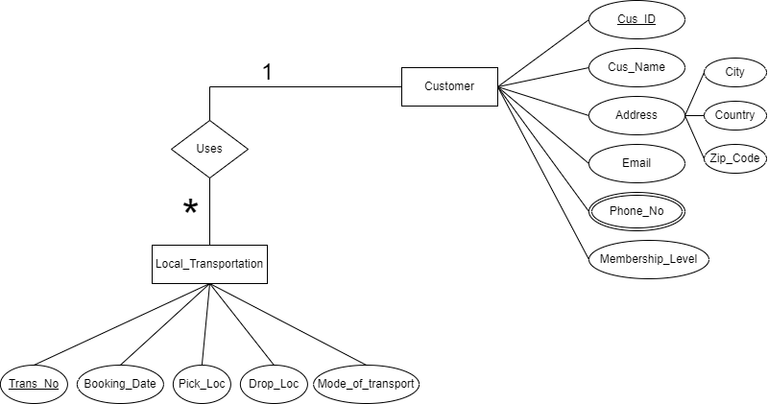

Fig-5: ER-Diagram for Customer – uses – Local_Transportation

Relation: One to Many
UNF: Cus_ID, Cus_Name, City, Country, Zip_code, Email, Phone_No, Membership_Level, Trans_No, Booking_Date, Pick_Loc, Drop_Loc, Mode_of_Transport

1NF: Multivalued attributes: Phone_No
Cus_ID, Cus_Name, City, Country, Zip_code, Email, Membership_Level, Trans_No, Booking_Date, Pick_Loc, Drop_Loc, Mode_of_Transport

2NF: 1. Cus_ID, Phone_No
2.Trans_No, Booking_Date, Pick_Loc, Drop_Loc, Mode_of_Transport,

Cus_ID
3.Cus_ID, Cus_Name, City, Country, Zip_code, Email, Membership_Level
3NF: 1. Cus_ID, City, Country, Zip_code
- Cus_ID, Phone_No
- Trans_No, Booking_Date, Pick_Loc, Drop_Loc, Mode of Transport,

Cus_ID
- Cus_ID, Cus_Name, Email, Membership_Level

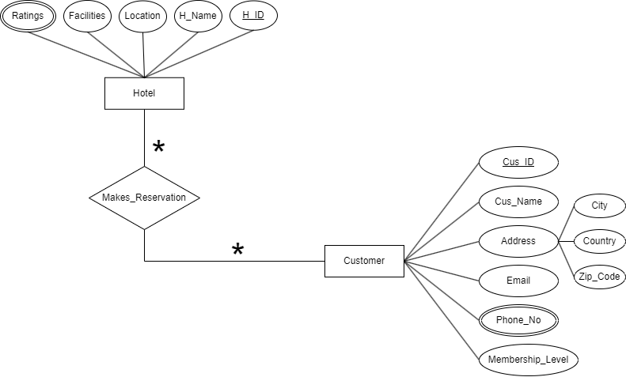

Fig-6: ER-Diagram for Customer – makes_reservation – Hotel

Relation: Many to Many

UNF: Cus_ID, Cus_Name, City, Country, Zip_code, Email, Phone_No, Membership_Level, H_ID, H_Name, Location, Facilites, Ratings
1NF: Multivalued attributes: Phone_No, Ratings
Cus_ID, Cus_Name, City, Country, Zip_code, Email, Phone_No, Membership_Level, H_ID, H_Name, Location, Facilites

2NF: 1. Cus_ID, Phone_No
2.H_ID, Ratings
3.Cus_ID, Cus_Name, City, Country, Zip_code, Email, Membership_Level
4.H_ID, H_Name, Location, Facilities, Cus_ID
3NF: 1. Cus_ID, City, Country, Zip_code
- Cus_ID, Phone_No
- H_ID, Ratings
- Cus_ID, Cus_Name, Email, Membership_Level
- H_ID, H_Name, Location, Facilities, Cus_ID

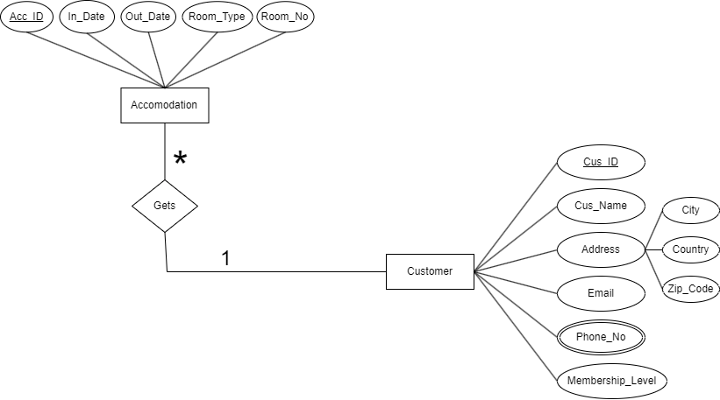

Fig-7: ER-Diagram for Customer – gets – Accommodation

Relation: One to Many

UNF: Cus_ID, Cus_Name, City, Country, Zip_code, Email, phone_no, Membership_Level, Acc_ID, In_Date, Out_Date, Room_Type, Room_No

1NF: Multivalued attributes: Phone_No
Cus_ID, Cus_Name, City, Country, Zip_code, Email, Membership_Level, Acc_ID, In_Date, Out_Date, Room_Type, Room_No

2NF: 1. Cus_ID, Phone_No
2.Acc_ID, In_Date, Out_Date, Room_Type, Room_No, Cus_ID
3.Cus_ID, Cus_Name, City, Country, Zip_code, Email, Membership_Level

3NF: 1. Cus_ID, City, Country, Zip_code
- Cus_ID, Phone_No
- Cus_ID, Cus_Name, Email, Membership_Level
- Acc_ID, In_Date, Out_Date, Room_Type, Room_No, Cus_ID

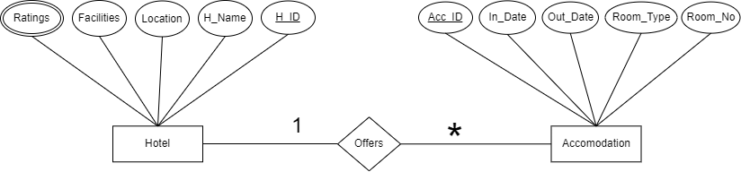

Fig-8: ER-Diagram for Hotel – offers – Accommodation

Relation: One to Many
UNF: Acc_ID, In_Date, Out_Date, Room_Type, Room_No, H_ID, H_name, location, Facilities, Ratings
1NF: Multivalued attributes: Ratings
Acc_ID, In_Date, Out_Date, Room_Type, Room_No, H_ID, H_name, location, Facilites

2NF: 1. H_ID, Ratings
2.Acc_ID, In_Date, Out_Date, Room_Type, Room_No, H_ID
3.H_ID, H_name, location, Facilites
3NF: 1. H_ID, Ratings
- Acc_ID, In_Date, Out_Date, Room_Type, Room_No, H_ID
- H_ID, H_name, location, Facilites

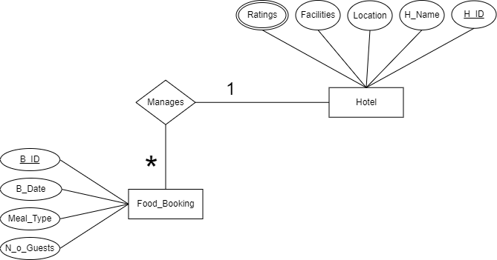

Fig-9: ER-Diagram for Hotel – manages – Food_Booking

Relation: One to Many

UNF: H_ID, H_name, location, Facilities, Ratings, B_ID, B_Date, Meal_Type, N_o_Guests
1NF: Multivalued attributes: Ratings
H_ID, H_name, location, Facilities, B_ID, B_Date, Meal_Type, N_o_Guests

2NF: 1. H_ID, Ratings
2.H_ID, H_name, location, Facilities
3.B_ID, B_Date, Meal_Type, N_o_Guests, H_ID
3NF: 1. H_ID, Ratings
- H_ID, H_name, location, Facilities
- B_ID, B_Date, Meal_Type, N_o_Guests, H_ID

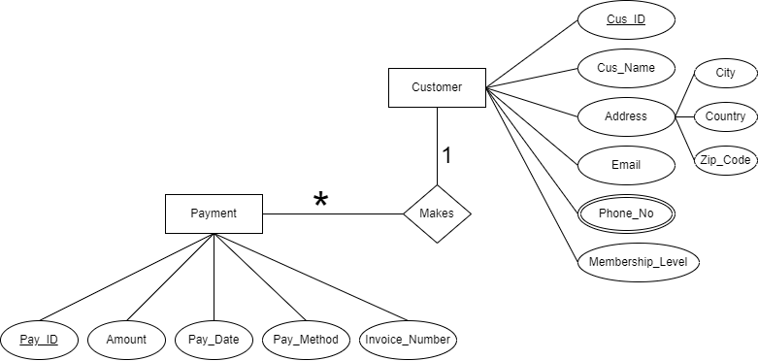

Fig-10: ER-Diagram for Customer – makes – Payment

Relation: One to Many
UNF: Cus_ID, Cus_Name, City, Country, Zip_code, Email, phone_no, Membership_Level, Pay_ID, Amount, Pay_Date, Pay_Method, Invoice_Number, Phone_No
1NF: Multivalued attributes: Phone_No
Cus_ID, Cus_Name, City, Country, Zip_code, Email, Membership_Level, Pay_ID, Amount, Pay_Date, Pay_Method, Invoice_Number_Phone_No

2NF: 1. Cus_ID, Phone_No
2.Cus_ID, Cus_Name, City, Country, Zip_code, Email, Membership_Level
3.Pay_ID, Amount, Pay_Date, Pay_Method, Invoice_Number, Cus_ID

3NF: 1. Cus_ID, City, Country, Zip_code
- Cus_ID, Phone_No
- Cus_ID, Cus_Name, Email, Membership_Level
- Pay_ID, Amount, Pay_Date, Pay_Method, Invoice_Number, Cus_ID

FINALIZATION
1. Agency ID, City, Country, Zip_code
2. Agency ID, Phone_No
3. E_ID, Skills
4. Agency ID, Agency_Name, Email
5. E_ID, E_Name, DOB, Job Title, Salary, Agency ID
6. Agency ID, City, Country, Zip_code
7. Cus_ID, City, Country, Zip_code
8. Agency ID, Phone_No
9. Cus_ID, Phone_No
10. Agency ID, Agency_Name, Email
11. Cus_ID, Cus_Name, Email, Membership_Level, Agency ID
12. Cus_ID, City, Country, Zip_code
13. Cus_ID, Phone_No
14. Trans_No, Booking_Date, Pick_Loc, Drop_Loc, Mode of Transport,
Cus_ID
15. Cus_ID, Cus_Name, Email, Membership_Level,Agency ID
16. Cus_ID, City, Country, Zip_code
17. Cus_ID, Phone_No
18. H_ID, Ratings
19. Cus_ID, Cus_Name, Email, Membership_Level
20. H_ID, H_Name, Location, Facilities, Cus_ID
21. Cus_ID, City, Country, Zip_code
22. Cus_ID, phone_no
23. Cus_ID, Cus_Name, Email, Membership_Level
24. Pay_ID, Amount, Pay_Date, Pay_Method, Invoice_Number,
Cus_ID
25. H_ID, Ratings
26. H_ID, H_name, location, Facilities ,Cus_id
27. B_ID, B_Date, Meal_Type, N_o_Guests, H_ID
28. Cus_ID, City, Country, Zip_code
29. Cus_ID, phone_no
30. Cus_ID, Cus_Name, Email, Membership_Level
31. Acc_ID, In_Date, Out_Date, Room_Type, Room_No, Cus_ID
32. H_ID, Ratings
33. Acc_ID, In_Date, Out_Date, Room_Type, Room_No, Cus_ID
34. H_ID, H_name, location, Facilities
35. Cus_ID, Phone_No
36. Flight_No, Dep_Country, Arr_Country, Dep_Time, Arr_Time
37. Cus_ID, City, Country, Zip_code
38. Cus_ID, Cus_name,Email, Membership_Level
39.Filght_no,Airline,Cus_id
TABLE CREATION
1. AGENCY_INFO:
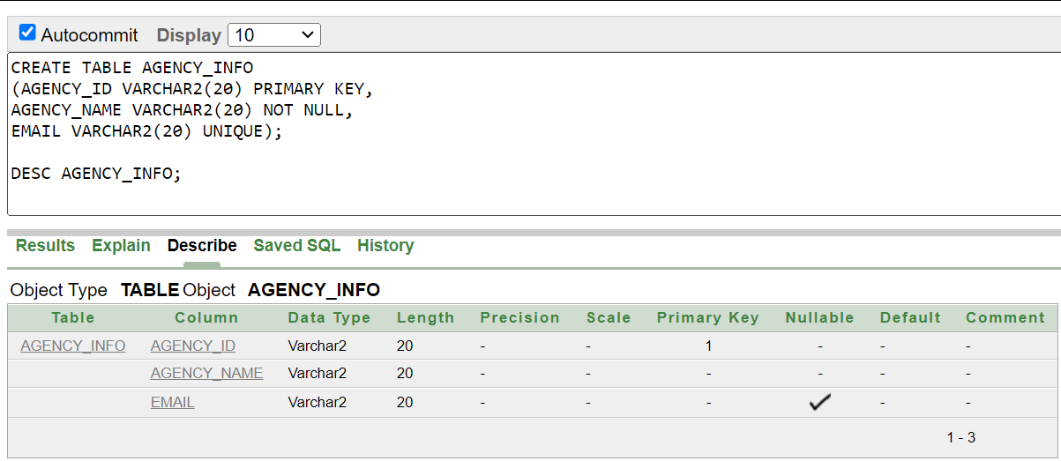

2. AGENCY_LOC:
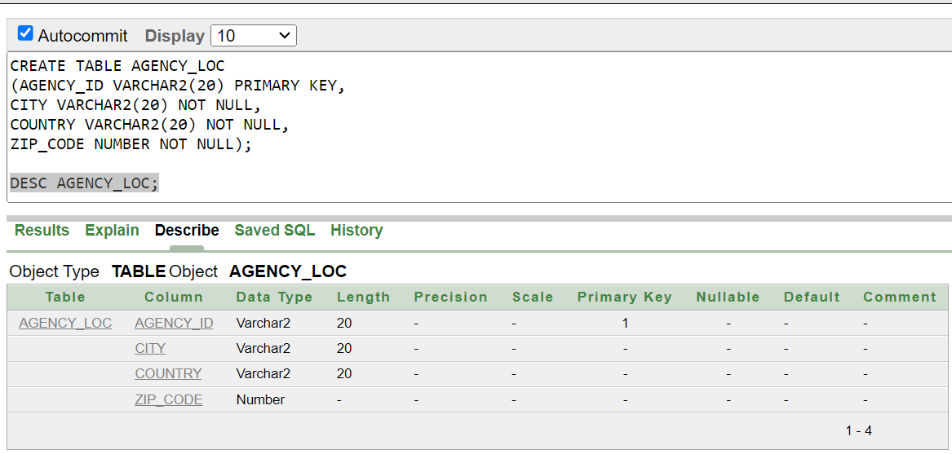

3. AGENCY_CON:
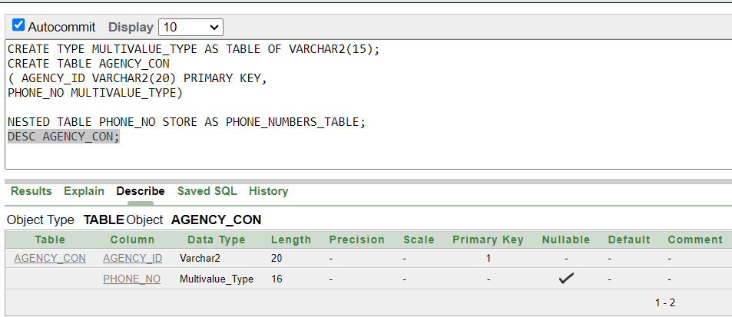

4. EMP_INFO:
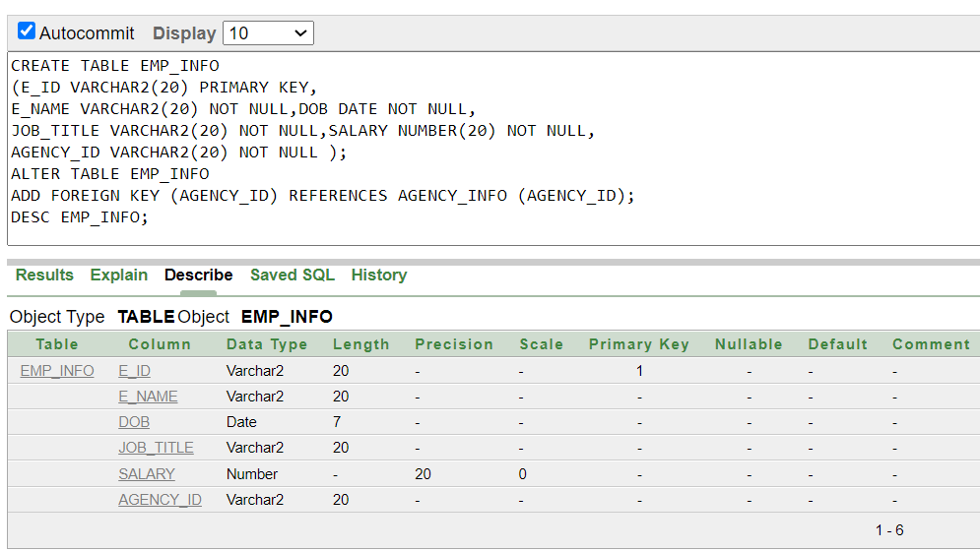

5. EMP_SKILL:
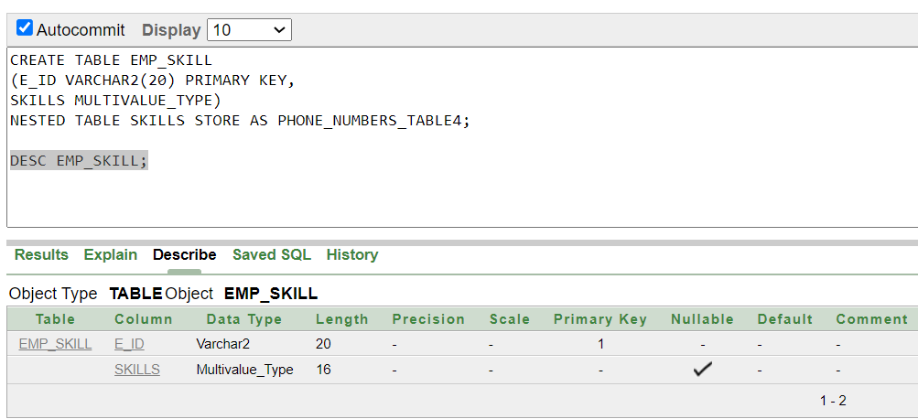

6. CUS_INFO:
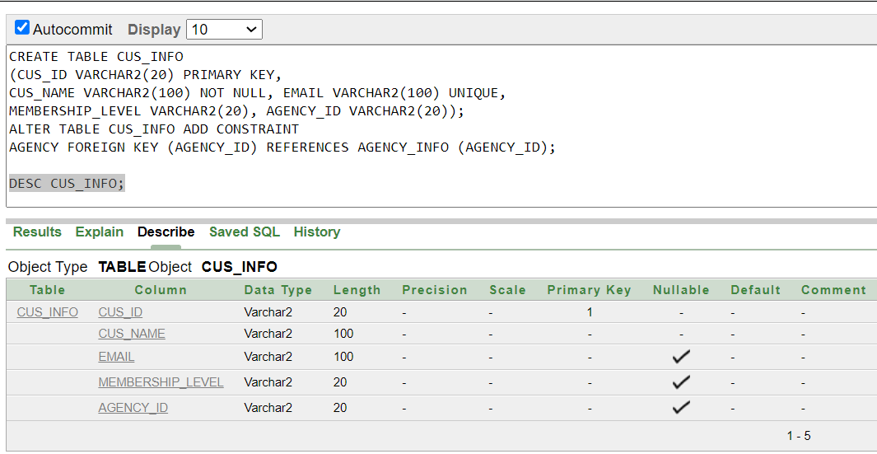

7. CUS_LOC:
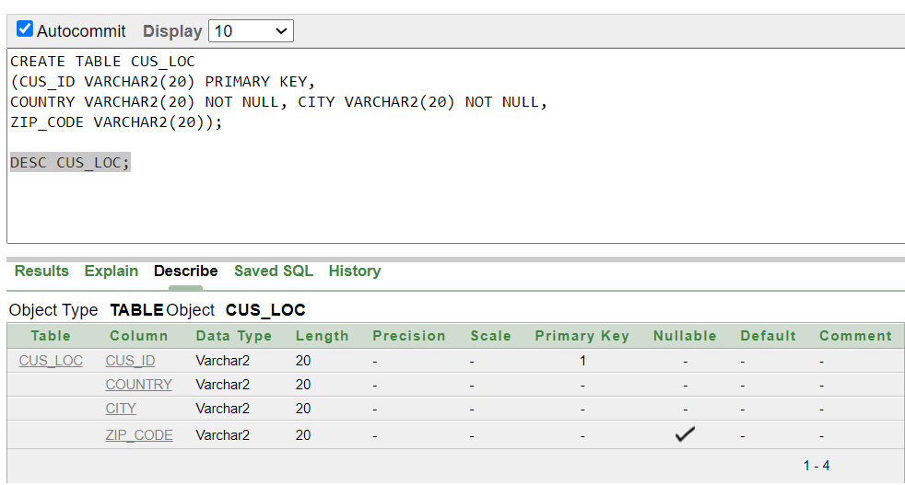

8.CUS_CON:
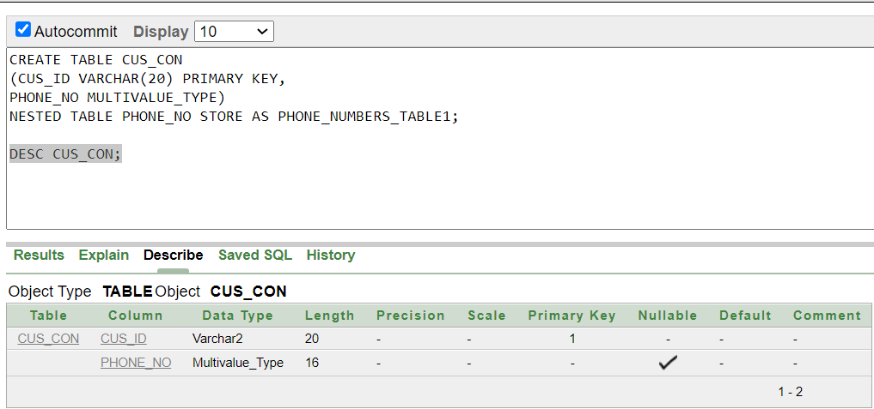

9.AIRLINE:
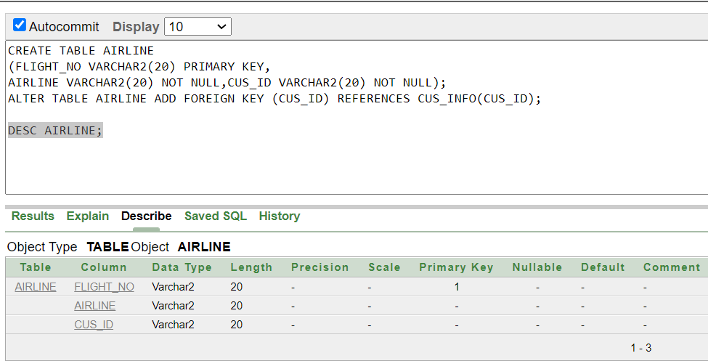

10. AIRLINE_INFO:
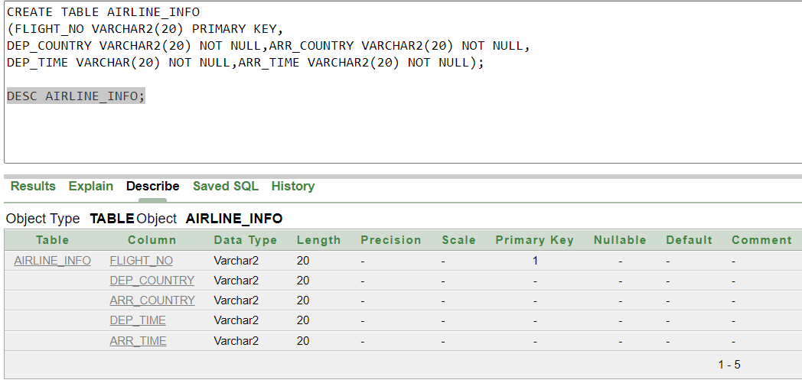

11. TRANSPORTATION:

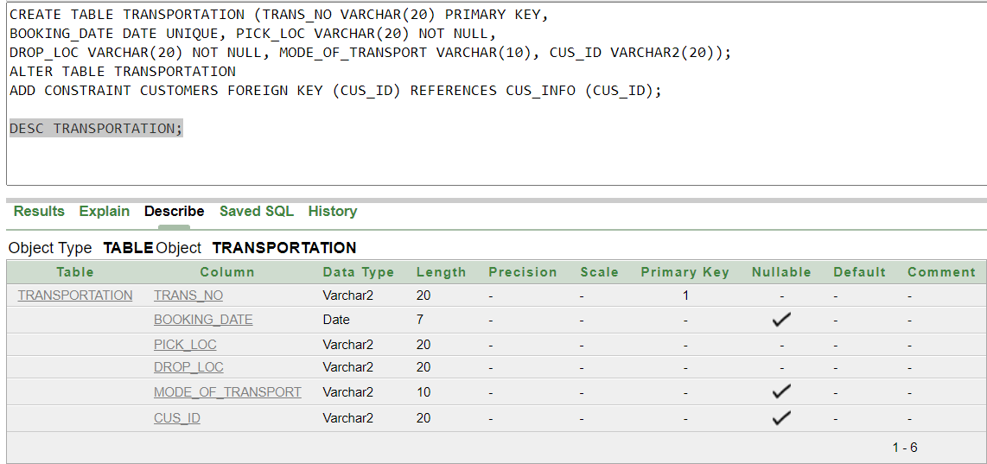

12.HOTEL_INFO:

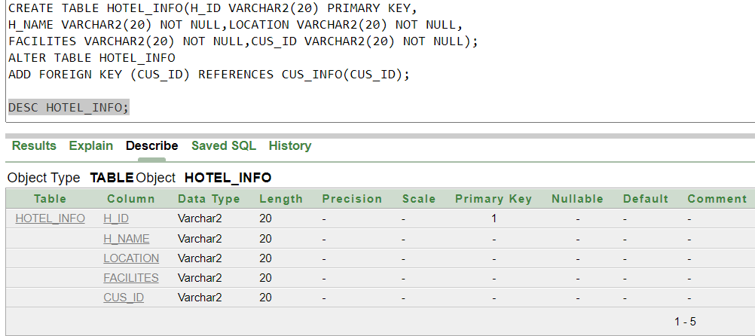

13.ACCOMODATION:

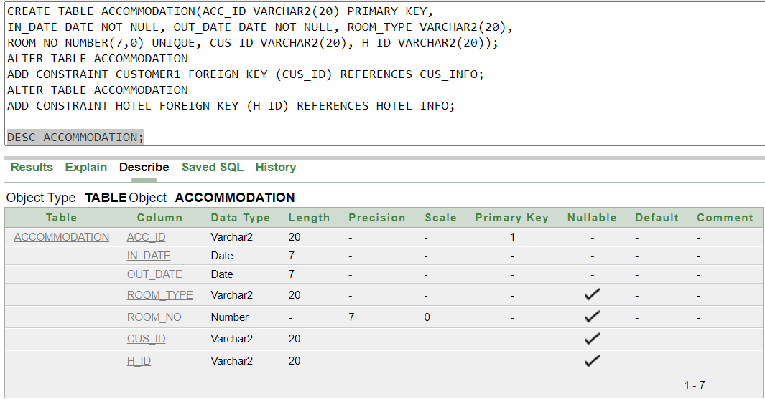

14. FOOD_BOOKING:

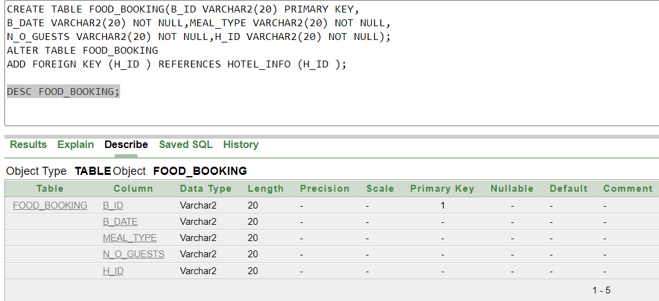

15. HOTEL_RATINGS:

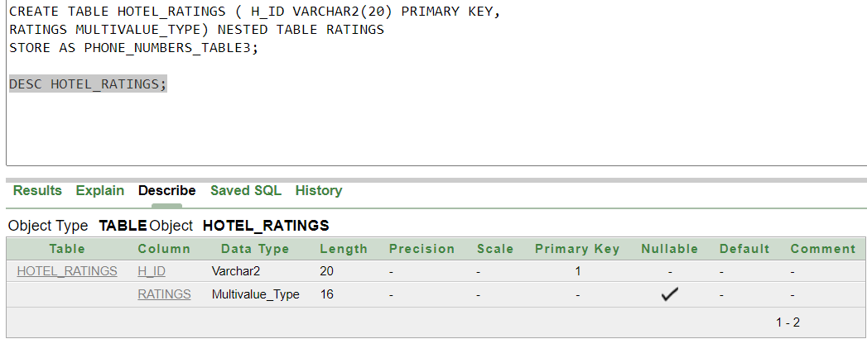

16.PAYMENT:

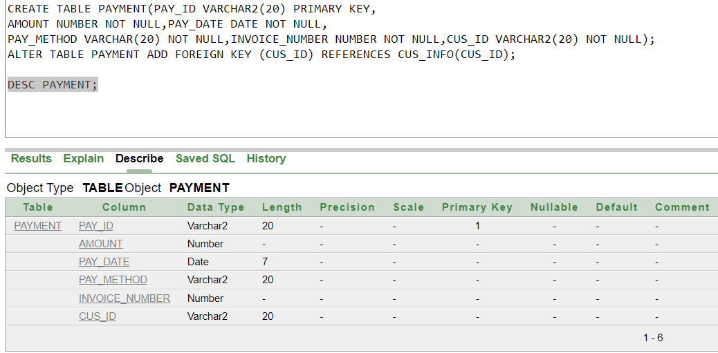

VALUE INSERTION
1. AGENCY_INFO:
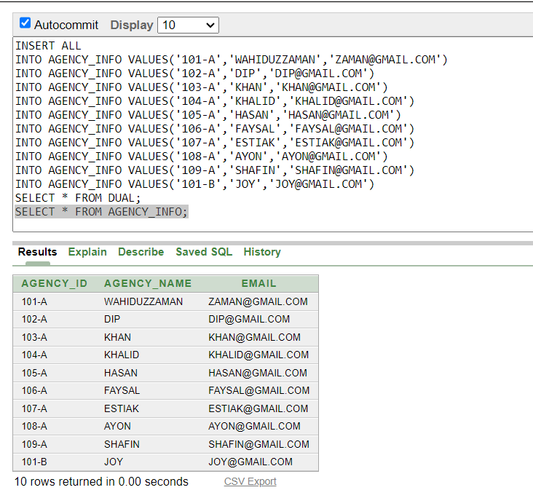
2. AGENCY_LOC:
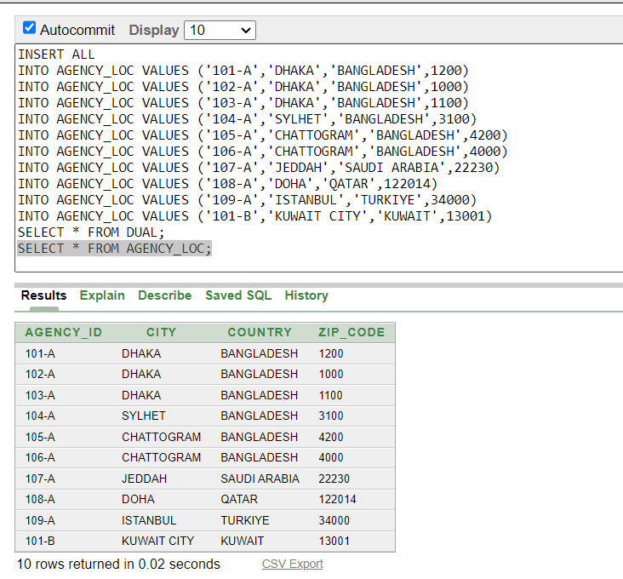

3. AGENCY_CON:
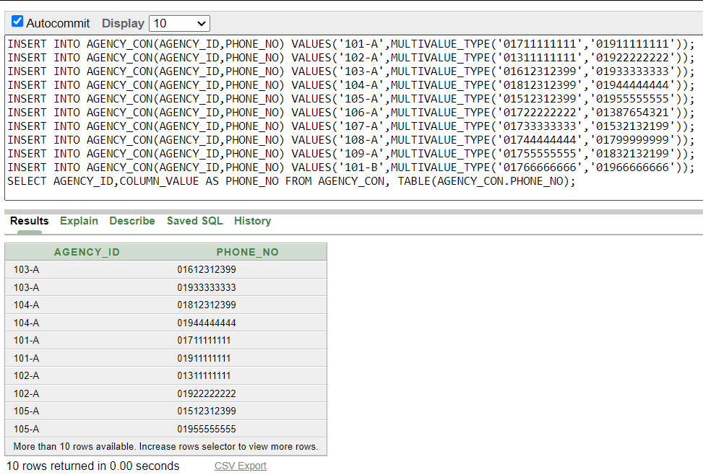
4. EMP_INFO:
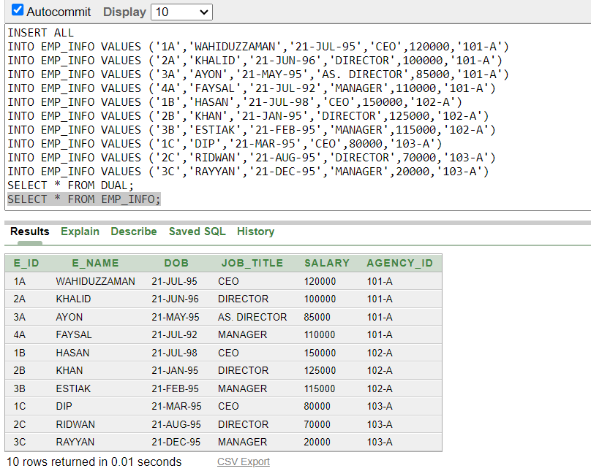
5. EMP_SKILL:
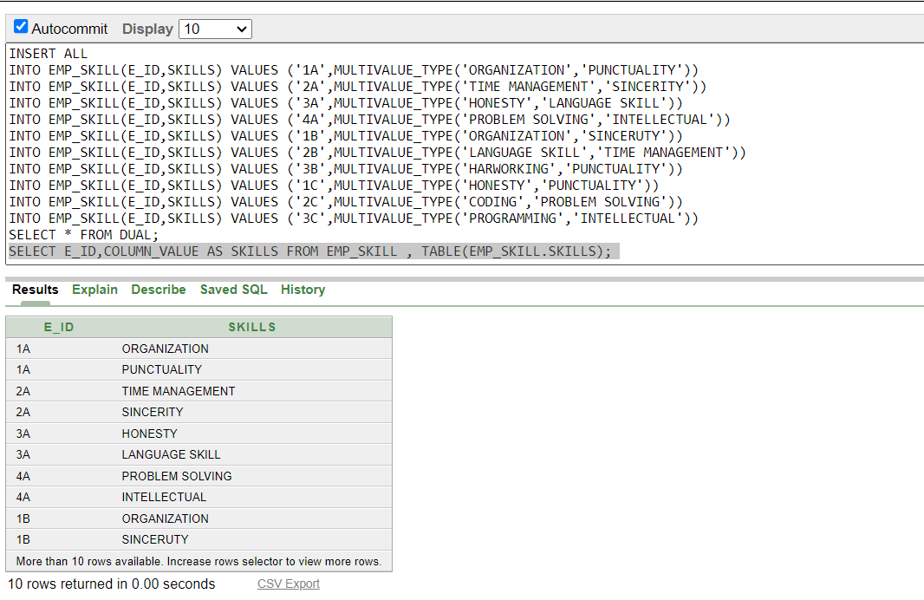

6. CUS_INFO:
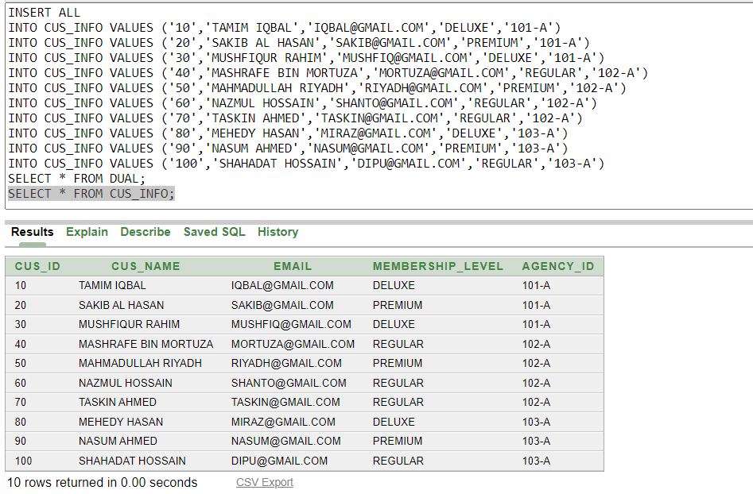
7. CUS_LOC:
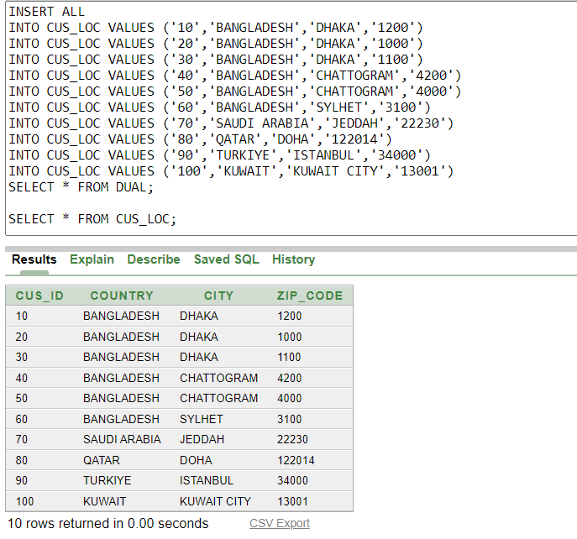
8.CUS_CON:
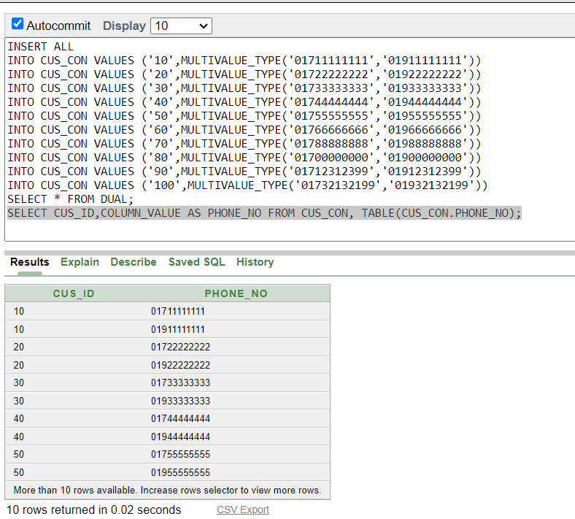
9.AIRLINE:
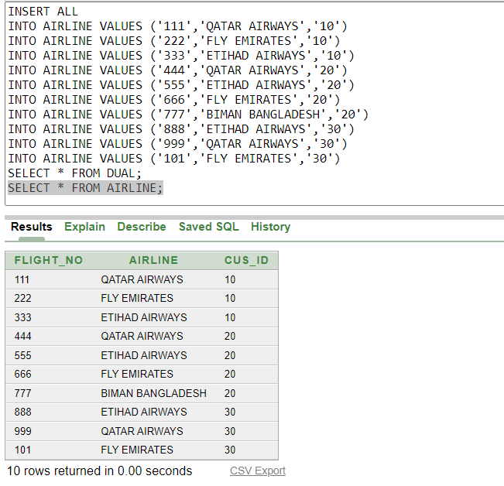
10. AIRLINE_INFO:
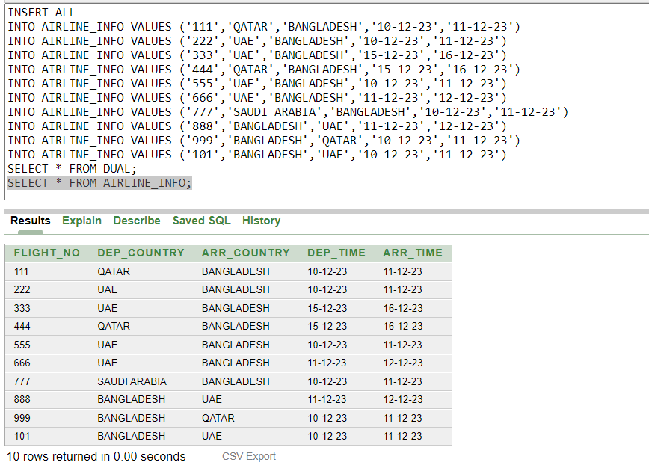
11. TRANSPORTATION:
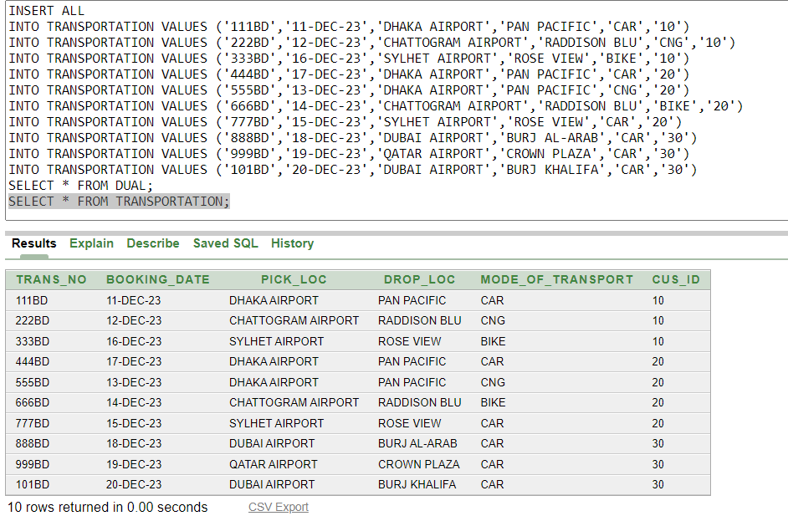

12.HOTEL_INFO:
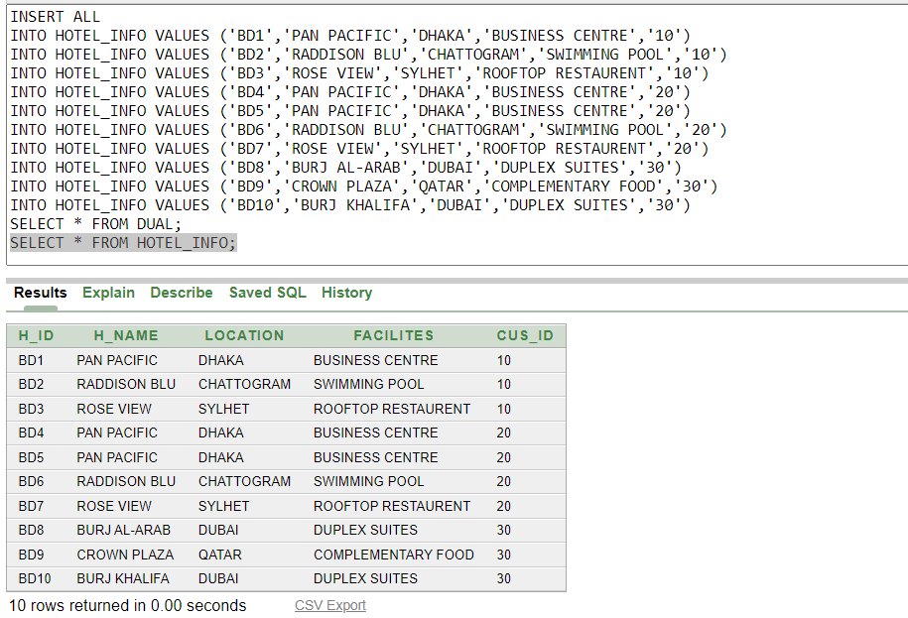

13.ACCOMODATION:
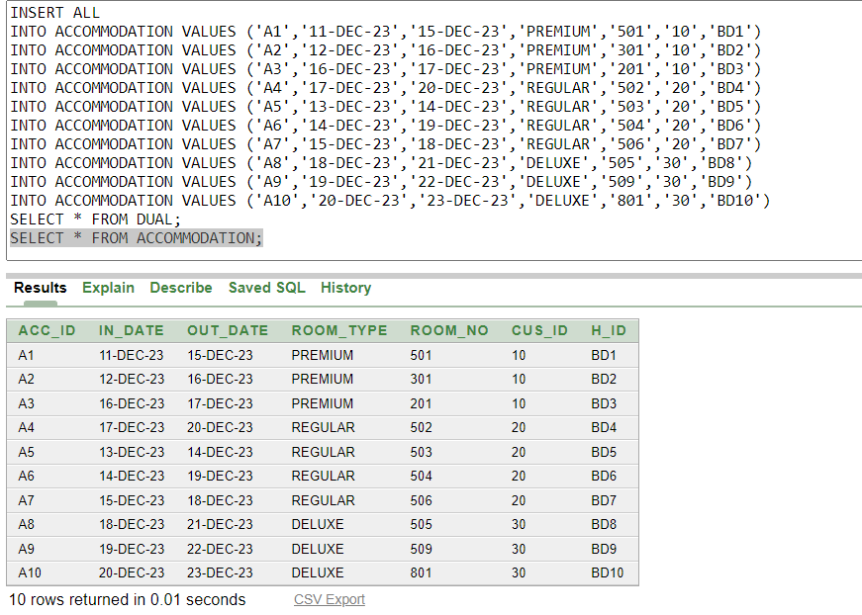
14. FOOD_BOOKING:
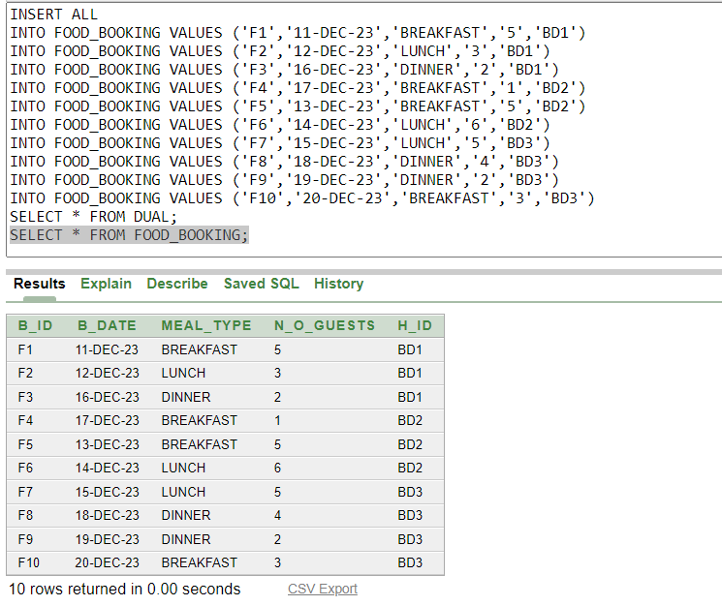
15. HOTEL_RATINGS:
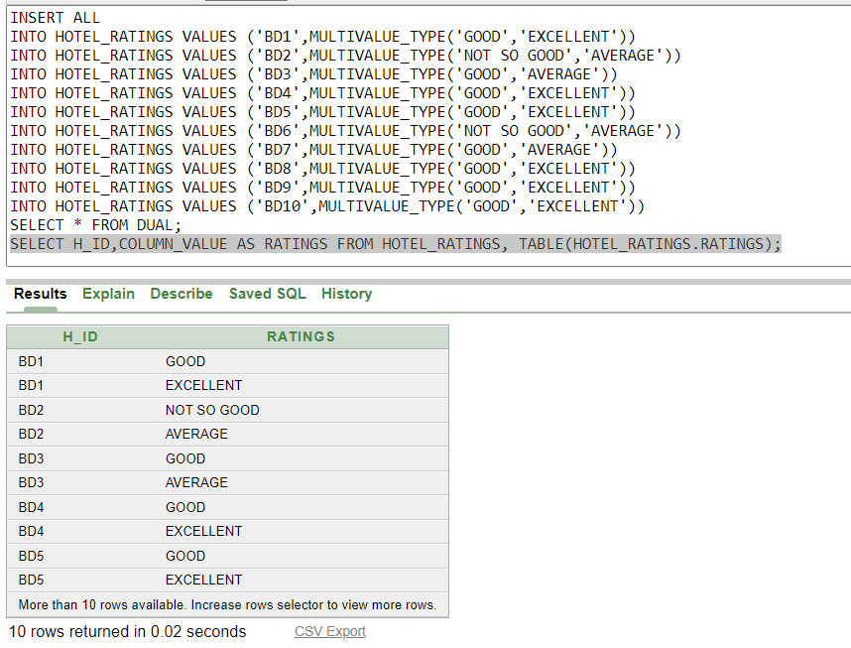

16.PAYMENT:
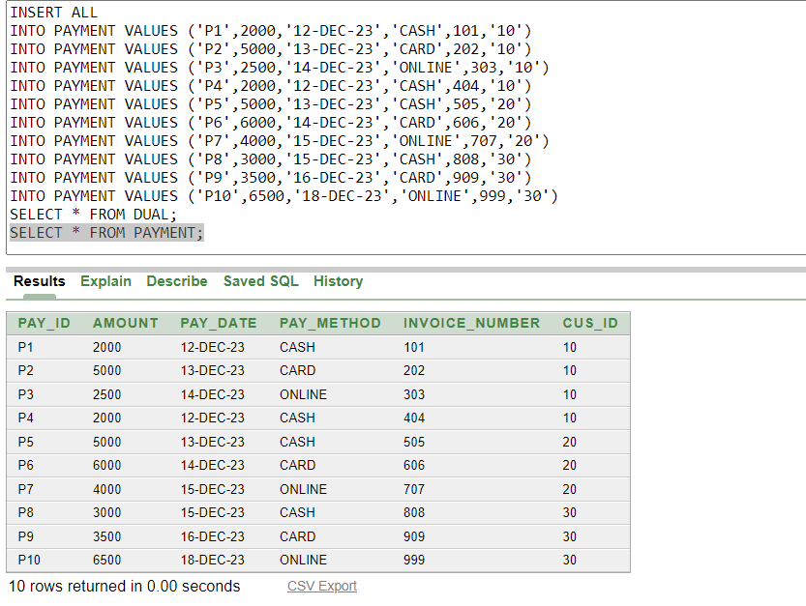
Query Testing
Single Row Query

Q-01:Show all information of Agency which ID ends with ‘A’.

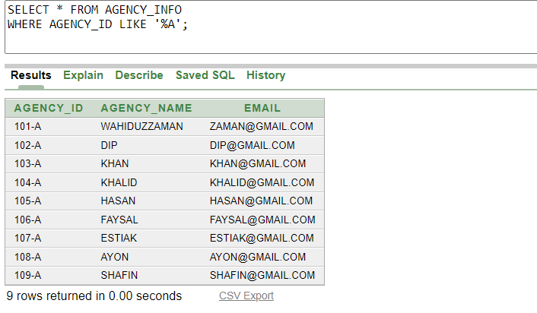

Q-02:Show customer’s payment ranges from 3000 to 6000.

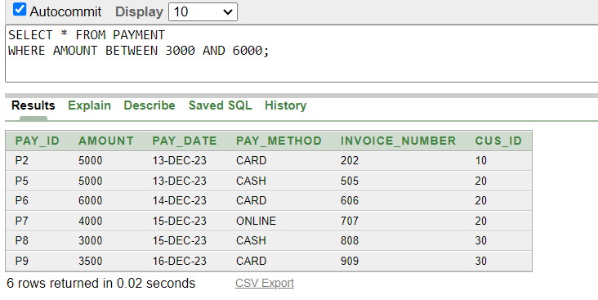

Q-03:Show the list of customers who have Deluxe,Premium membership.

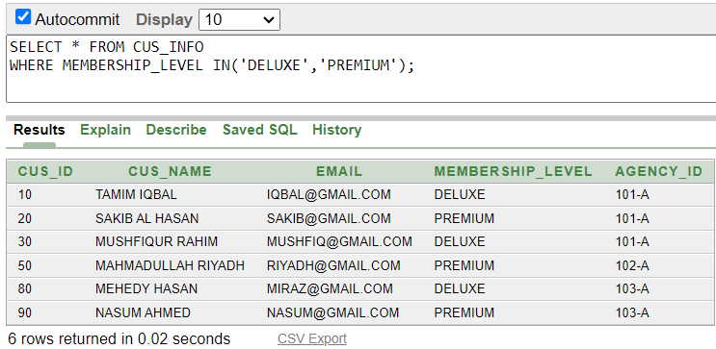

Multiple Row Query

Q-04.Show the salaries of CEOs who earn more than 120,000.

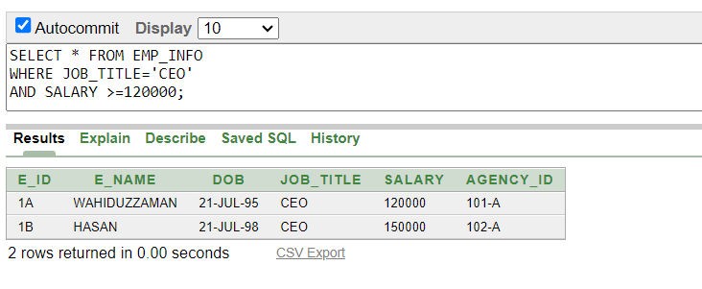

Q-05.Show the information of employees who are CEO or earn more than 120,000.

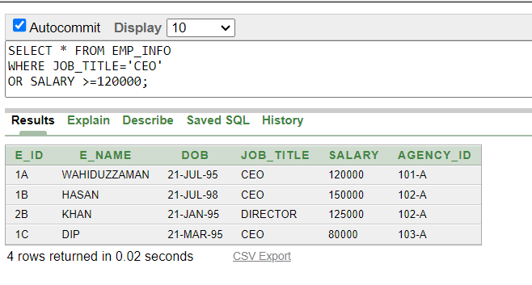

Q-06.Show the information of the employees who are not CEO.Also create a temporary column and name it “Annual Salary” and arrange the table by descending order based on salary.

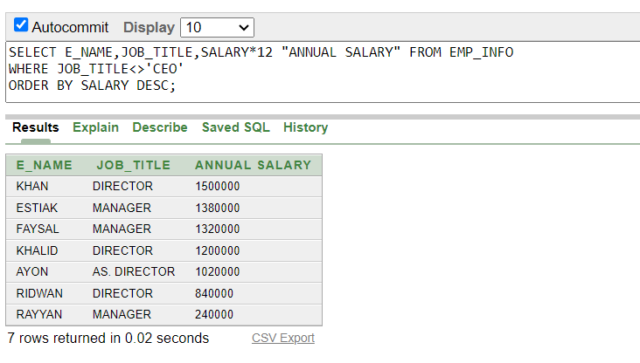

Sub-query(Single Row)

Q-07.Show the customers information who owns same membership as of “TAMIM IQBAL”.

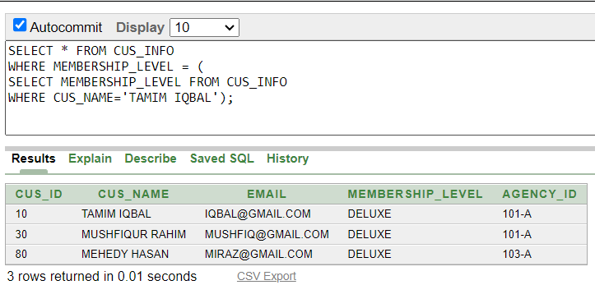

Q-08.Show the information of employees who are at the same position as of “WAHIDUZZAMAN” and earns more than “KHALID”.

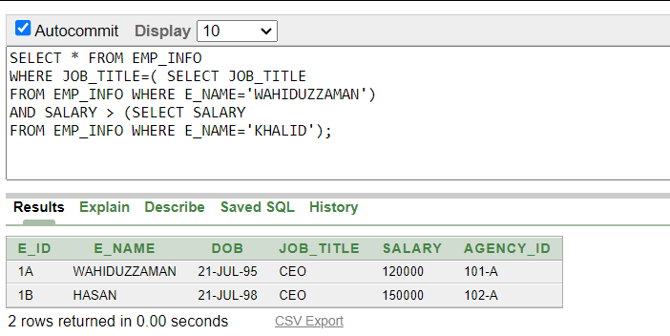

Sub-Query (Multiple Row)

Q-09.Show Payment information more than any of the customer id 10.

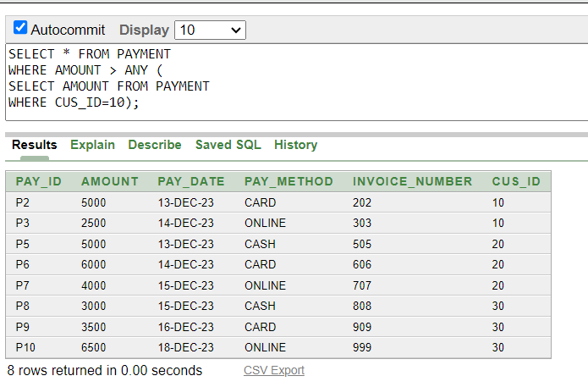
Q-10.Show Payment information more than all the customer id 10.

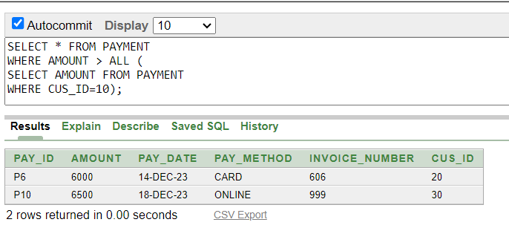

Q-11.Show the list of Payments which are as same as customer id 10.

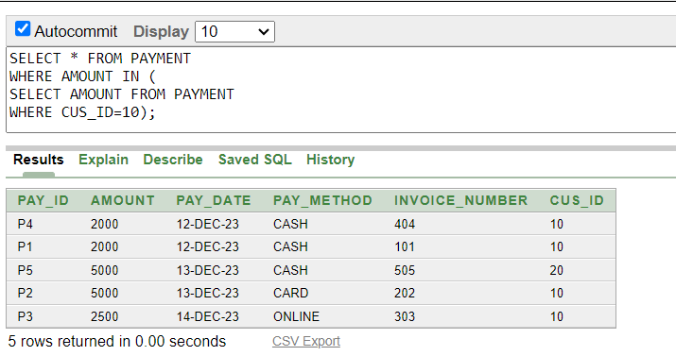

Aggregate Function Query

Q-12.Show maximum and minimum salary from Emp_Info table using group by clause.

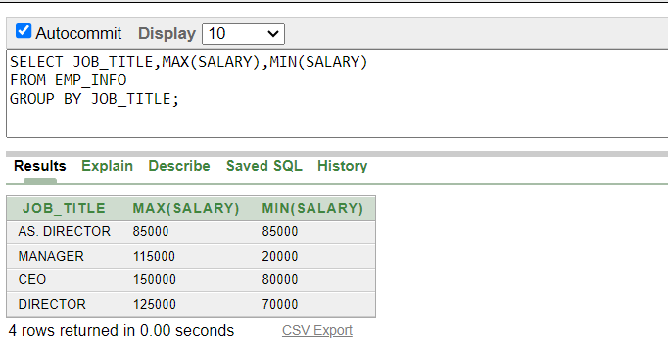

Q-13.Show maximum,minimum,average and sum of the salaries of the managers from Emp_info Table.
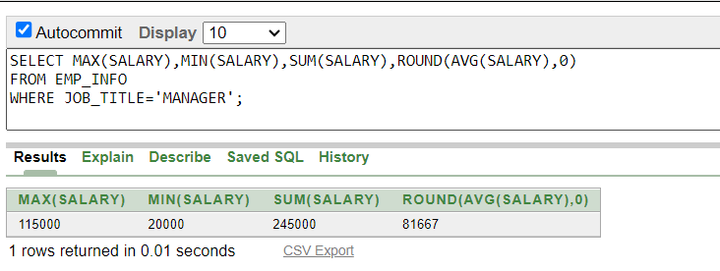

Q-14.Show average amounts of payment which is more than 3000 using group by clause.
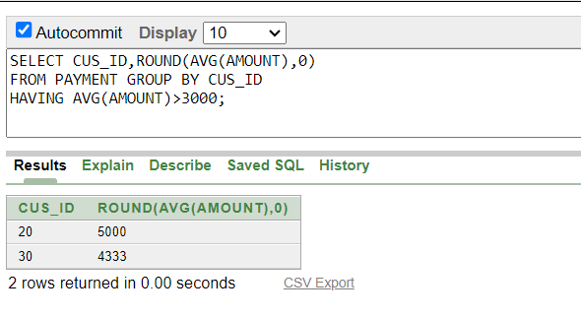 Q-15.Show the maximum average salary from Emp_Info Table.
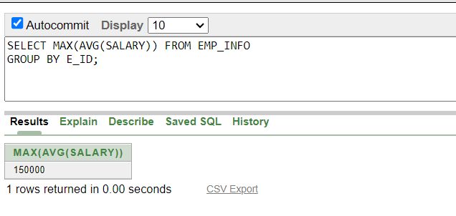
Q-16.Show the number of hotels situated in Dhaka.
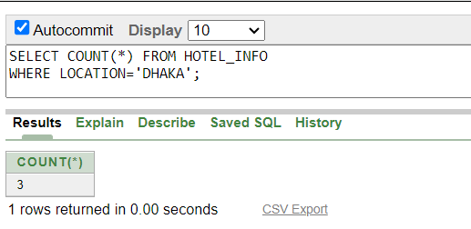

Joining Query

Q-17.Show all the payments information of all the customers. (Equi)
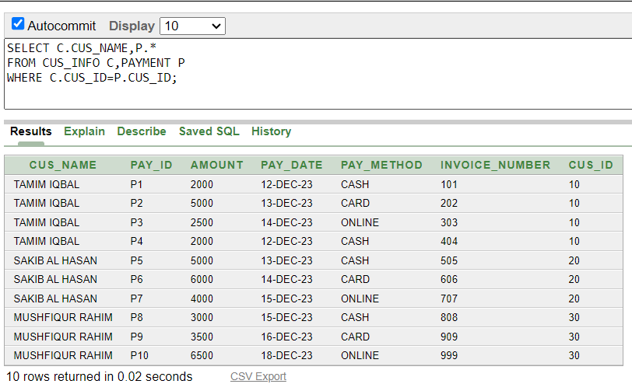

Q-18.Show flights and hotels information together of the customers.(Equi)
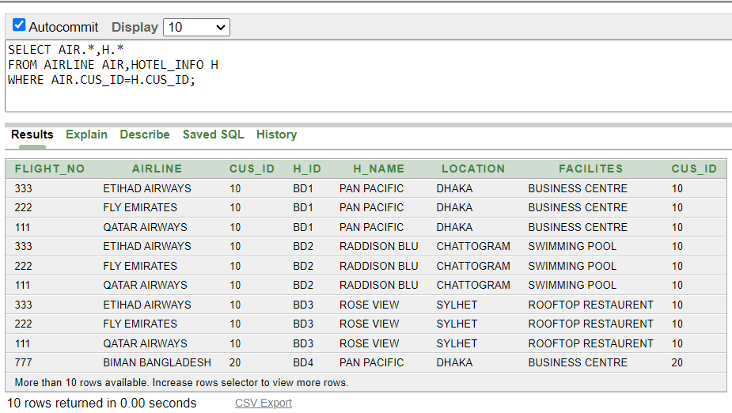

Q-19.Show the agencial information of all the employees.(Equi-joins)

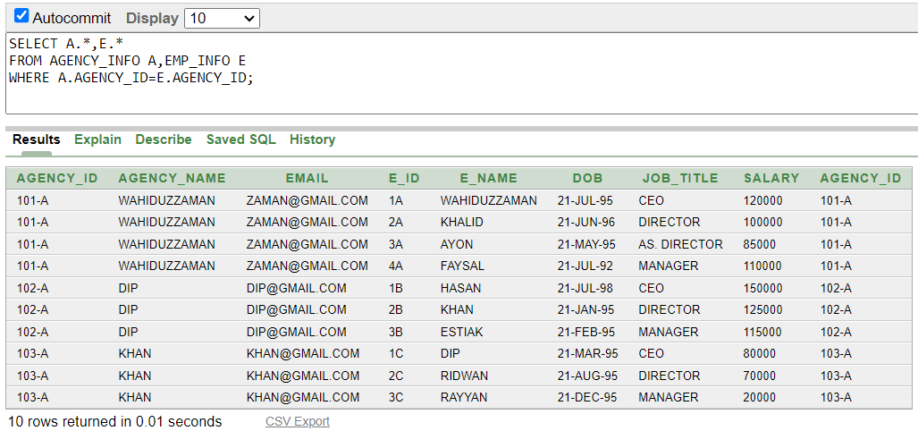

Q-20.Get all the employees who works in the same position as of ‘WAHIDUZZAMAN’.(self-joins)

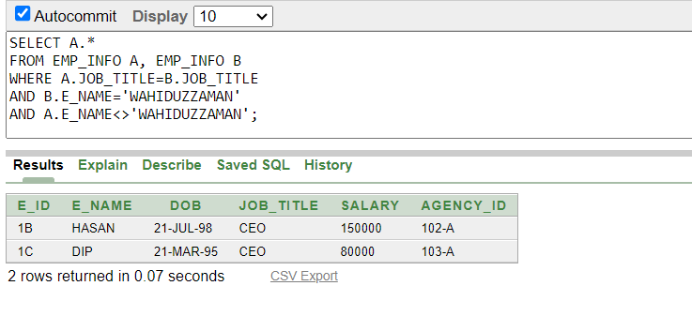

Q-21.Get all the matching records from Agency and Employee table.
(Full outer-joins)

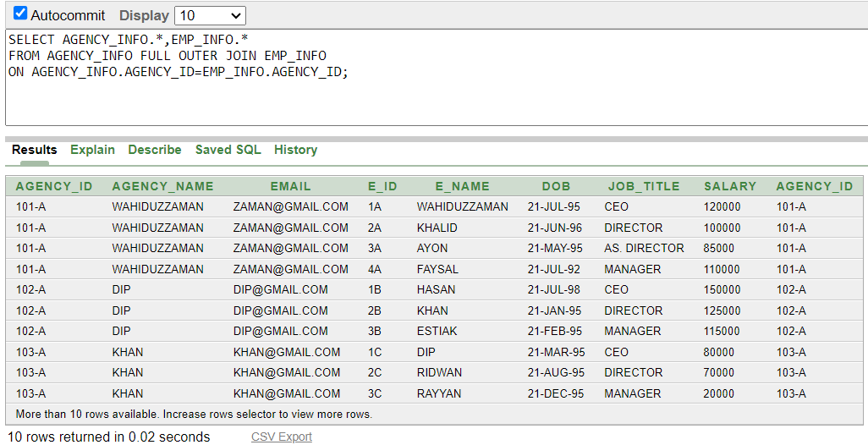
Q-22. Display all the agencial information for all the existing employees using left outer join.

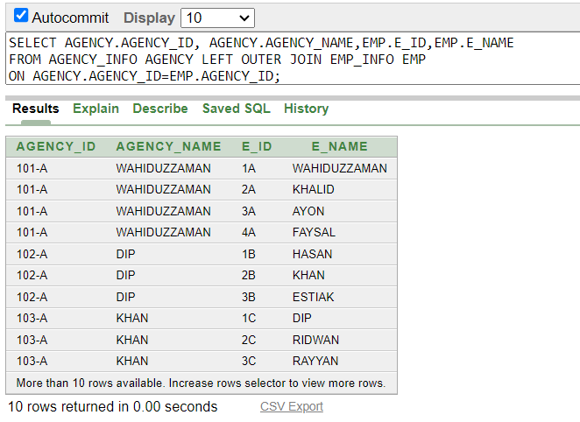

Q-23. Display all the agencial information for all the existing employees using right outer join.

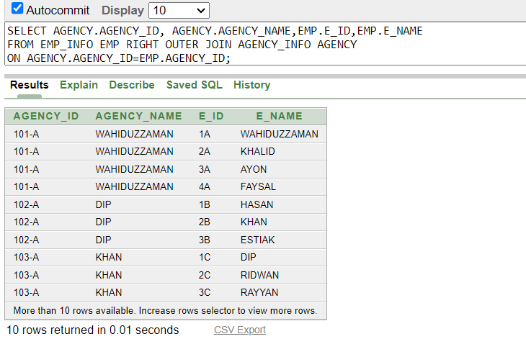

View Query

Q-24. Create a view called Airways based on flight_no,Airline and customer id where customer id is 10.

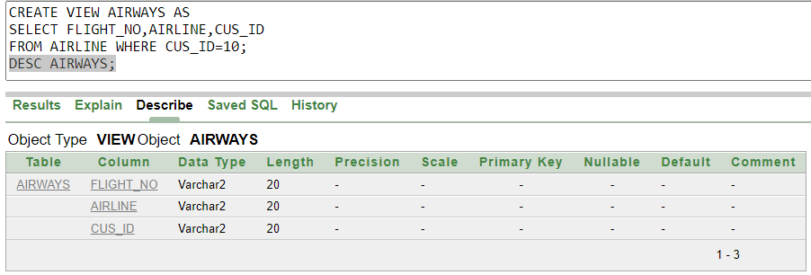

Q-25. Create a view called Housing based on types of room,room no,check in and check out dates.

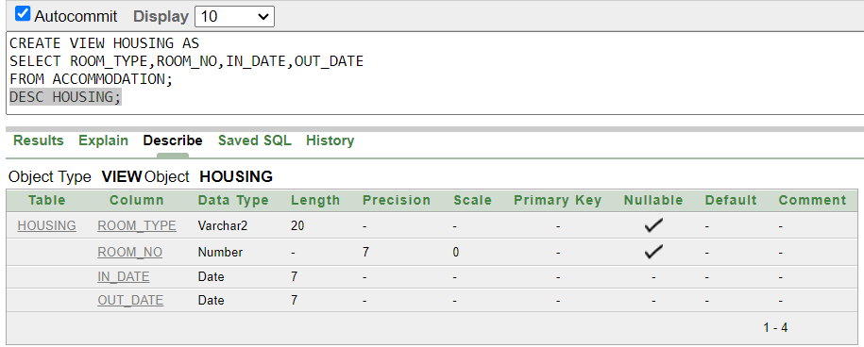

Q-26. Create a view “Transaction” that contains Pay_ID, Amount, Pay_method , Cus_ID. Level the columns respectively as Payment_ID,Value, Pay_Way, Customer_ID. Make Sure that no DML operation can be performed on this view.

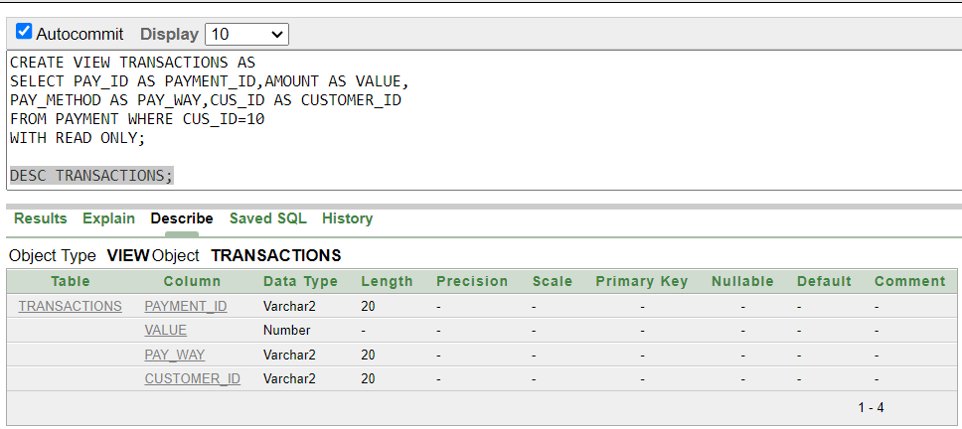

Database Connection
Process:
To connect a Database with JDBC we need 3 things.

- MySQL java connector (jar file). You can go to (Maven Repository: mysql » mysql-connector-java (mvnrepository.com)) and download any version you like.
- We need XAMPP. Xampp can be downloaded from here (Download XAMPP (apachefriends.org)).
- We can use any IDE. In our project netbeans has been used.

- Start the XAMPP app then start the both Apache and MySQL. Next go to MySQL admin panel.
- Now create a Database, inside of it create a table and insert the values in the table.

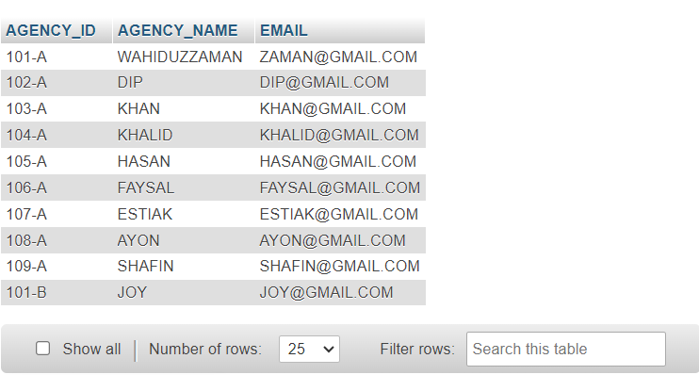

- Next we opened the IDE (Netbeans).
- Create a project. Add the jar file to the libraries.
- In source package create folder.In the folder create a java file.
- Now to write the code we need to understand the steps of Database connection.
- Register driver.
- Connect the database.
- Create a statement.
- Execute the query().
- Connection close().

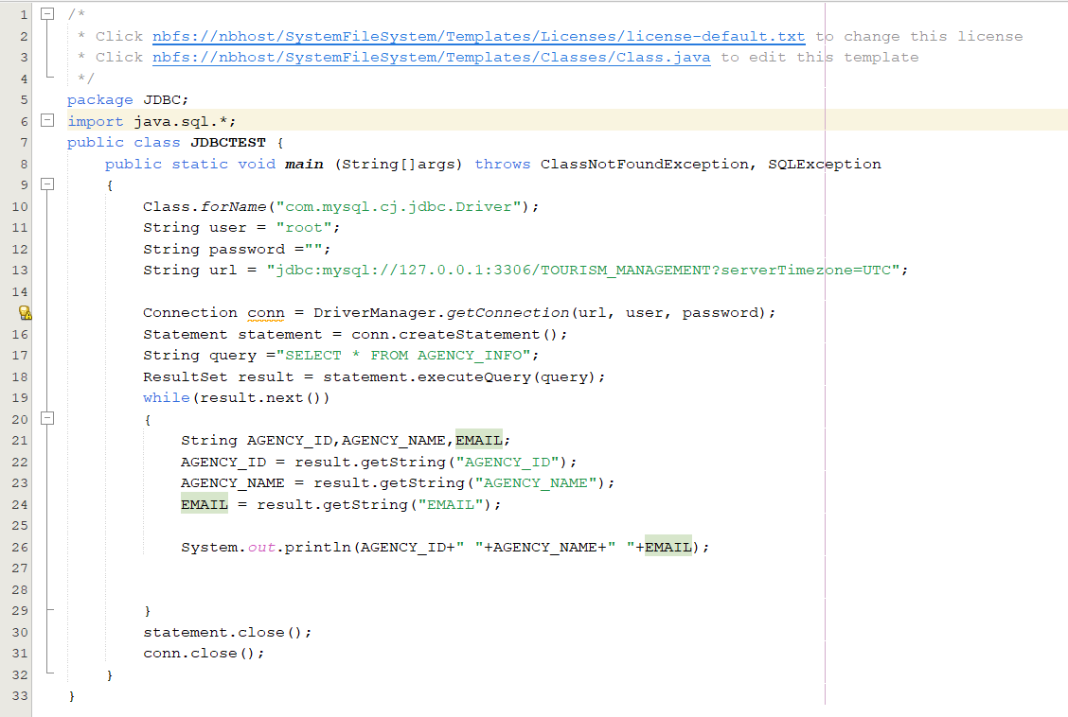

Fig: Connection Code

D. The output is:
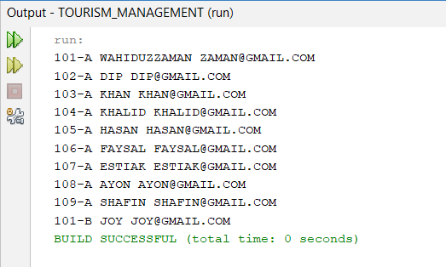

- Finished.

About Database Connection & Its Features
A database connection is like a virtual bridge between a computer program (like a website or application) and a storage area for information, known as a database. It allows the program to interact with and retrieve data from the database.
Key Features:
- Connection String:
  - Think of it as a secret code that the program uses to find the database. It contains details like where the database is located and how to get in.
- Connection Pooling:
  - Imagine a shared pool of workers. Instead of hiring new workers every time a job needs to be done, the program reuses existing workers to save time and effort.
- Authentication:
  - Similar to showing a badge to enter a secure area, authentication ensures that only authorized users or programs can access the database.
- Transaction Management:
  - Transactions are like making several moves in a game. Either all the moves happen together, or none of them do. This ensures that the database stays in a good state.
- Error Handling:
  - When something goes wrong (like a misspelled command), error handling helps the program understand and respond appropriately without crashing.
- Concurrency Control:
  - Imagine people sharing a document. Concurrency control ensures that changes made by one person don't mess up what another person is doing.
- Database Drivers:
  - Just as you need a specific key for different locks, database drivers are like keys that help the program communicate with different types of databases.
- SSL/TLS Encryption:
  - It's like sending a secret letter in a locked box. SSL/TLS encryption ensures that information traveling between the program and the database is secure and private.
- Connection Timeouts:
  - This is like setting a timer. If the program can't connect to the database within a certain time, it gives up to prevent waiting forever.
- Connection States:
  - Think of a connection as a light switch—it can be off, on, or doing something. Understanding connection states helps the program manage its interactions with the database effectively.
In simple terms, database connection features are like a set of rules and tools that help programs talk to databases in a secure, reliable, and efficient way.

Conclusion
Our tourist management system project is designed to work as a database schema for any travel management system. We made an effort to incorporate all entity kinds and store their data in the most straightforward manner imaginable. Through this project, we have applied the theoretical knowledge we learned in this Introduction to Database course to a real-world project. The information we have gained from this project and the training will hopefully be useful in developing any database-related projects we work on in the future. We are also very excited to work on this project and willing to add more features as well.

